Supplementary 2

Figure S1. Co-authorship network for «vaccine + coronavirus» publications 2019-2020 on the A, Scopus database; B, PubMed database; C, Dimensions database (by authors)
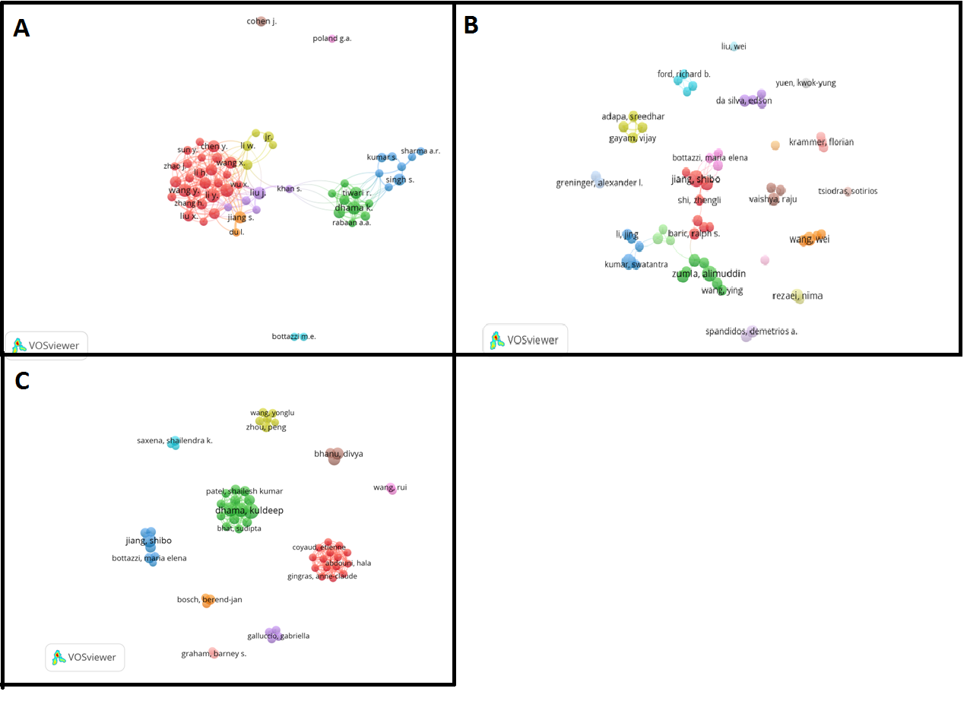

Figure S2. Co-authorship network for «vaccine + coronavirus» publications 2019-2020 on the A, Scopus database; B, PubMed database; Dimensions database (by organizations)
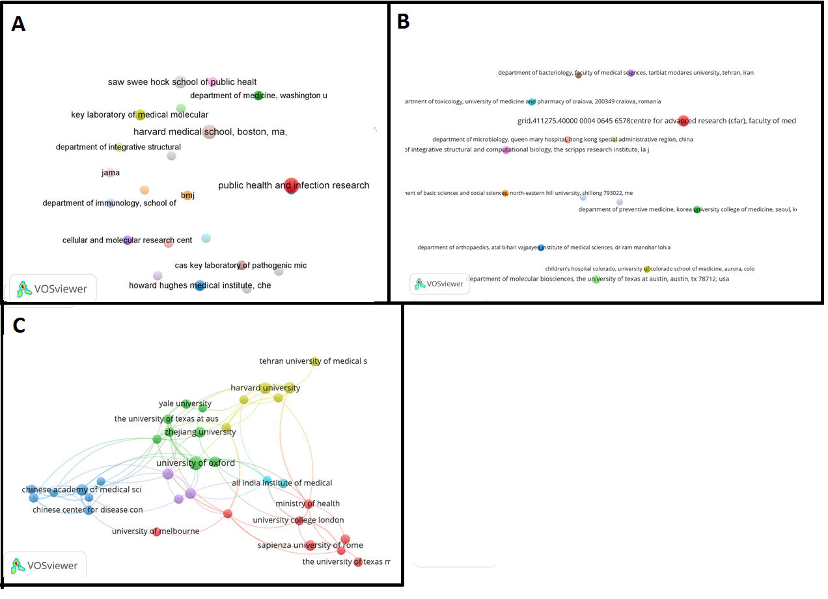

Figure S3. Co-occurrence network map of 39 keywords for «vaccine + coronavirus» publications 2019-2020 on the A, Scopus database; B, PubMed database; C, Dimensions database
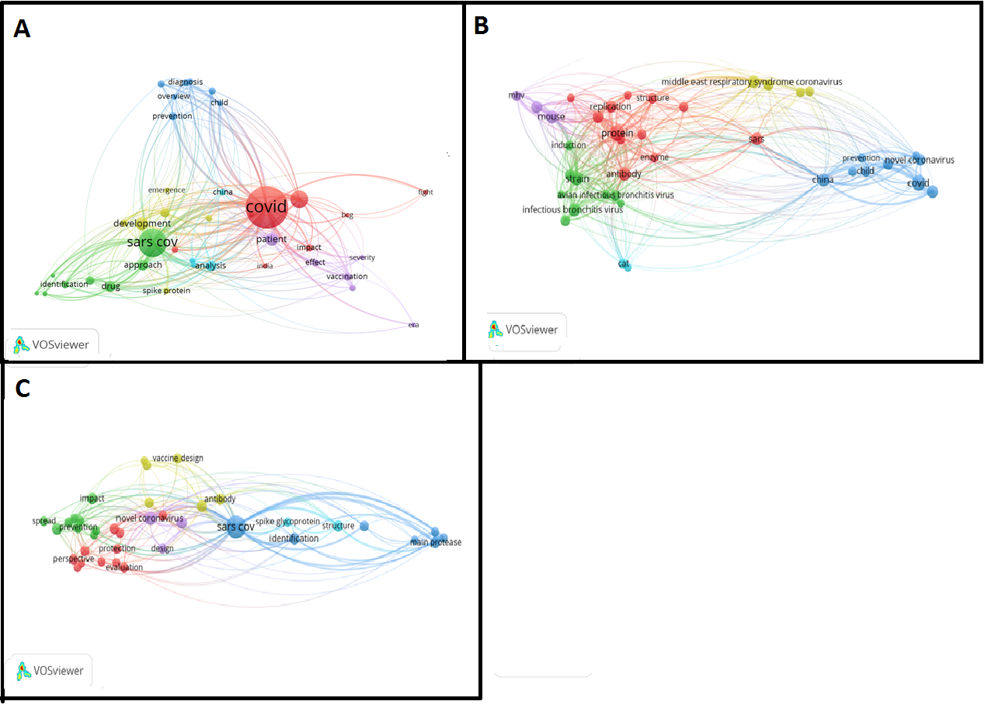

Figure S4. Co-occurrence network map of 475 keywords for «vaccine + coronavirus» publications 2019-2020 on the A, Scopus database; B, PubMed database; C, Dimensions database
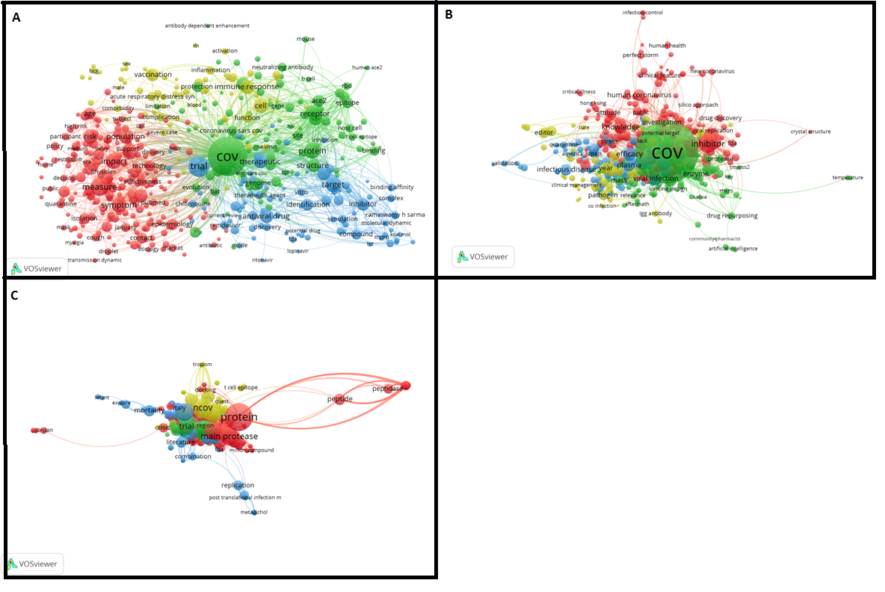

Figure S5. The relationship of the terms of lexical groups between corpora from different bases.

Figure S6. The most common terms in publications related to research in the field of "vaccine+coronavirus" on the PubMed database, time of appearance.
